***How to create a “GIT HUB” account?***

STEP-1

Search for ‘git hub‘ in a website

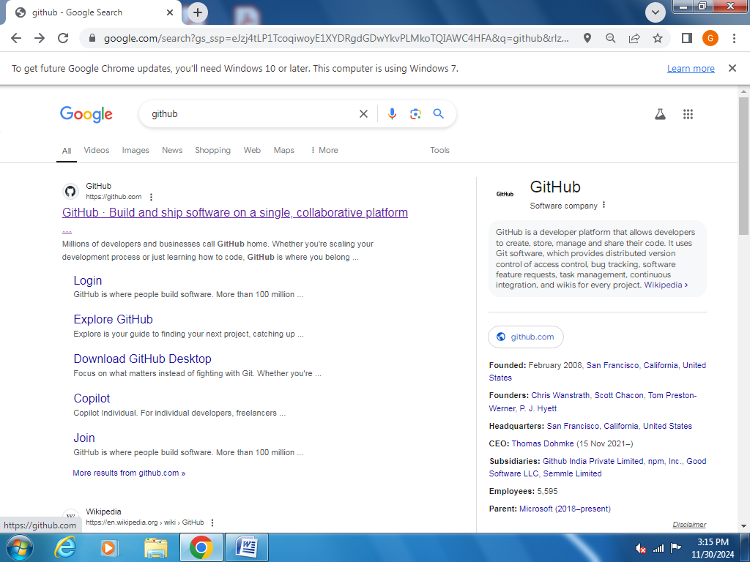

STEP-2

Open github.com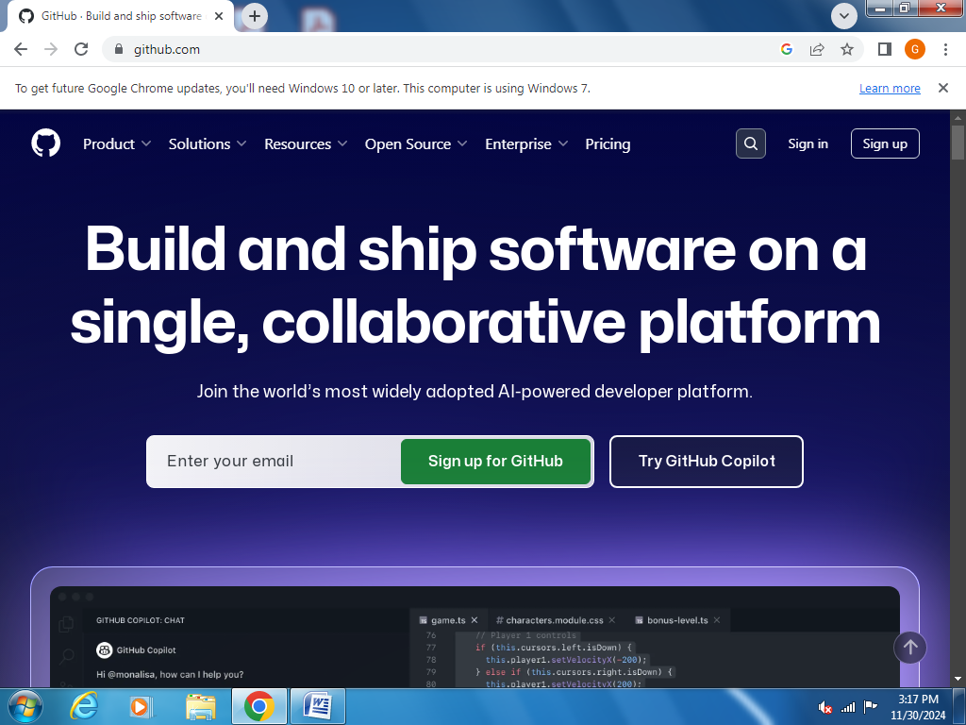

STEP-3

Click on sign up, the shown below appears.

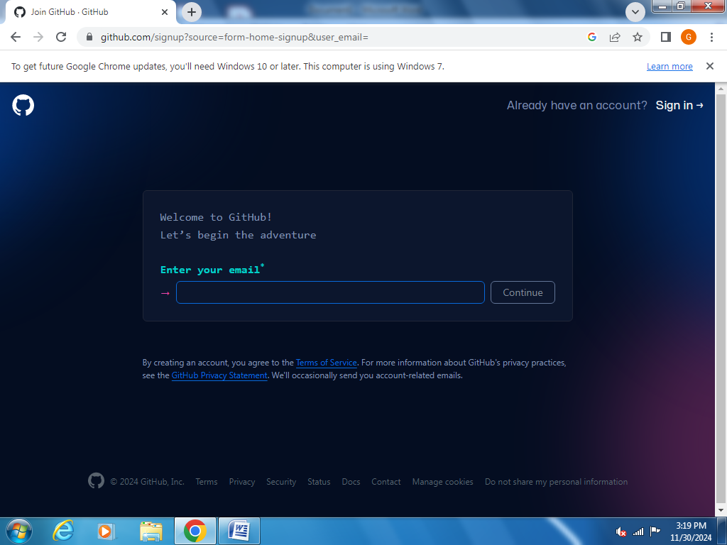

STEP-4

Enter your email, password and username.

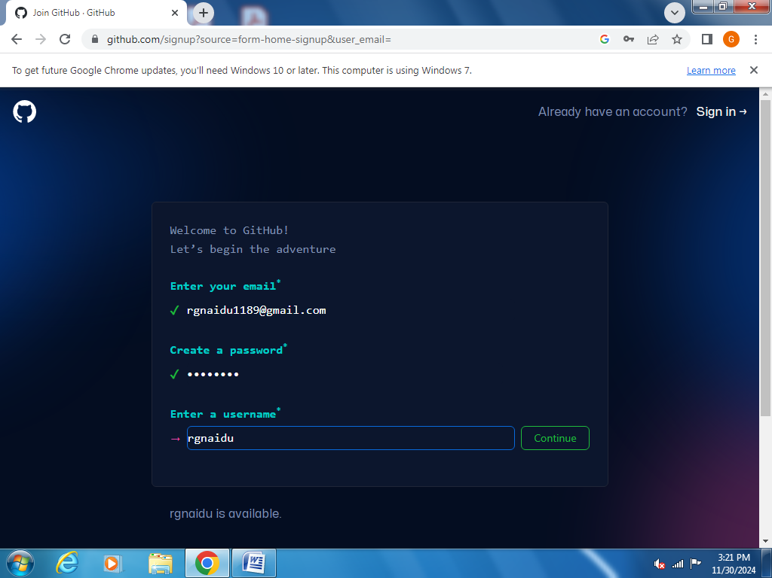

STEP-5

Click on continue and click verify

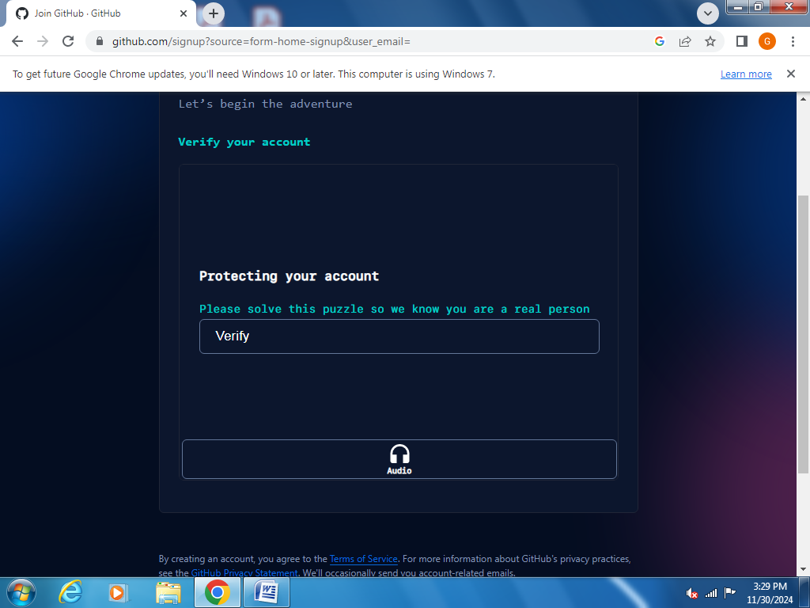

STEP-6

Now the page will verify if your are a human or robot and after that Enter the otp received to your mail

STEP-7

Sign in to your github account by entering username and password

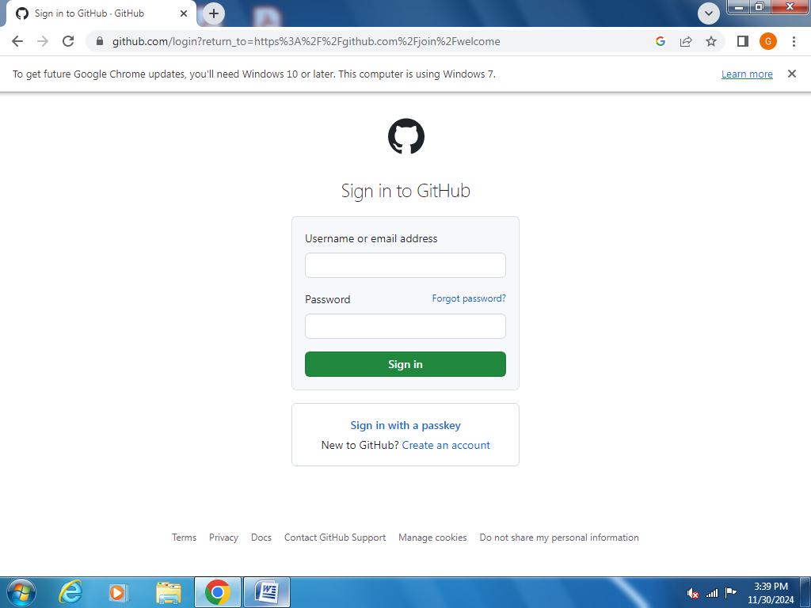

STEP-8

Fill your personalization details or click on skip personalization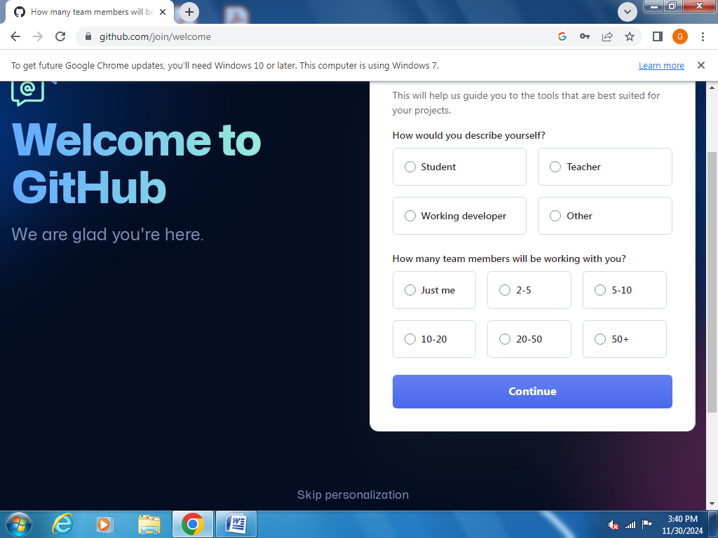

STEP-9

The below shown is the home page of git hub and click on create repository

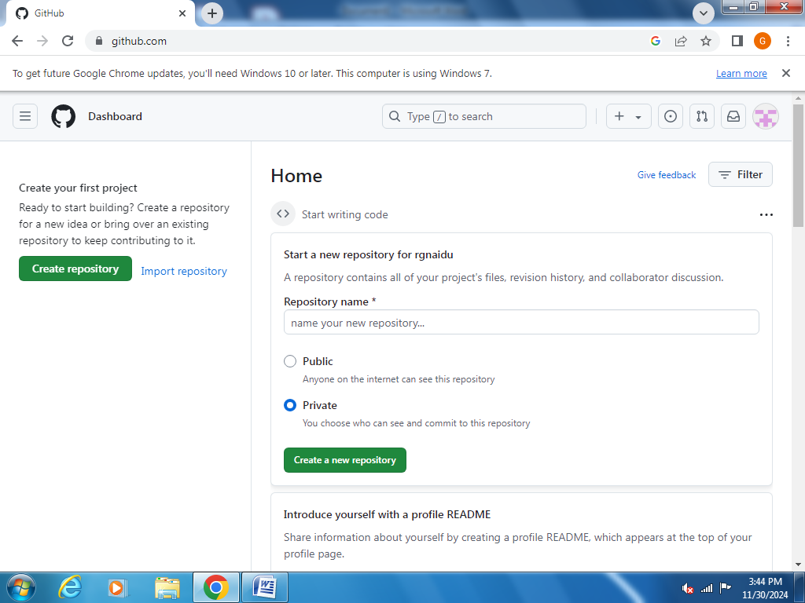

STEP-10

Give a name to your repository and select public or private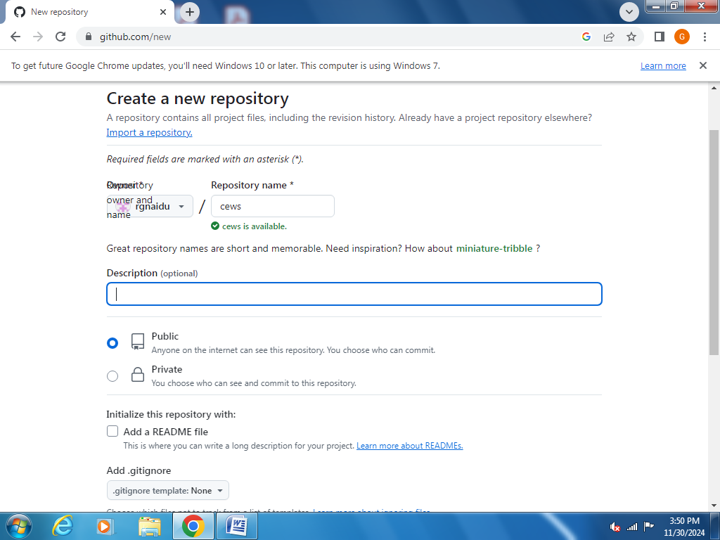

STEP-11

Click on uploading an existing file

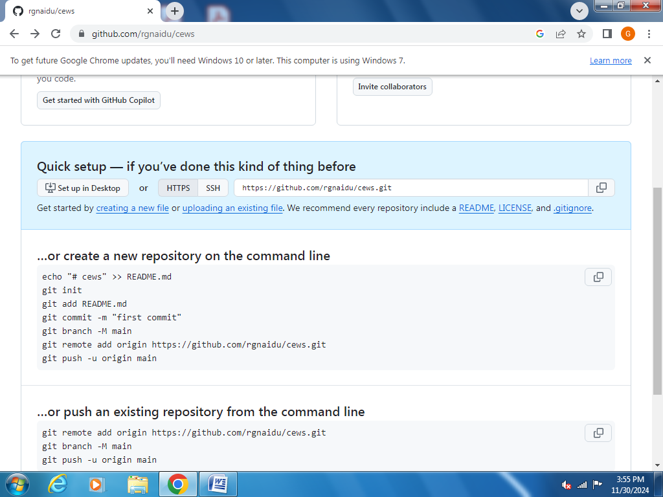

STEP-12

Add your file there and click on commit changes and your file is uploaded